Project Planning Phase
Project Planning Template (Product Backlog, Sprint Planning, Stories, Story points)

Date | 10 july 2026
Team ID
Project Name | Electrical vehicle charge and range Analysis
Maximum Marks | 5 Marks

Product Backlog, Sprint Schedule, and Estimation (4 Marks)
Use the below template to create product backlog and sprint schedule
Sprint | Functional  Requirement (Epic) | User Story  Number | User Story / Task | Story Points | Priority | Team  Members
Sprint-1 | Data Setup &  Cleaning | USN-1 | As an analyst, I want to upload and clean the dataset so it is ready for visualization in Tableau | 2 | High | You +  Teammates
Sprint-1 | Basic Visualization  Design | USN-2 | As a user, I want to build bar and donut charts to compare categories and promotion impact | 3 | High | You
Sprint-1 | Dashboard Filtering | USN-3 | As a user, I want to add filters (Promotion, Demographics, Traffic) to interact with dashboards | 2 | Medium | You
Sprint-2 | Advanced  Visualizations | USN-4 | As a user, I want to visualize data with funnel and highlight tables to show customer and sales behavior | 4 | High | You + Peer
Sprint-2 | Waterfall and Area  Chart Design | USN-5 | As a user, I want to see sales contribution and trend across product categories and traffic zones | 3 | Medium | You
Sprint-3 | Story Building | USN-6 | As a presenter, I want to create a Tableau Story to communicate findings step-by-step | 2 | Medium | You
Sprint-3 | Export &  Presentation | USN-7 | As a user, I want to export visuals and present the complete dashboard for stakeholders | 2 | High | You

Project Tracker, Velocity & Burndown Chart: (4 Marks)
Sprint | Total Story  Points | Duration | Sprint Start Date | Sprint End Date  (Planned) | Story Points  Completed | Sprint Release Date  (Actual)
Sprint-1 | 7 | 6 Days | 01 Feb 2025 | 06 Feb 2025 | 7 | 06 Feb 2025
Sprint-2 | 7 | 6 Days | 07 Feb 2025 | 12 Feb 2025 | 7 | 12 Feb 2025
Sprint-3 | 4 | 6 Days | 13 Feb 2025 | 18 Feb 2025 | 4 | 18 Feb 2025







Velocity:
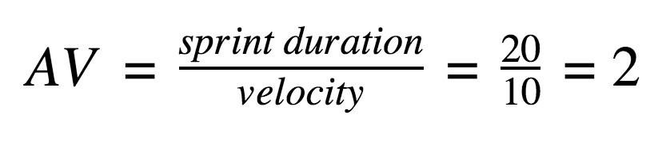

Burndown Chart:
A burn down chart is a graphical representation of work left to do versus time. It is often used in agile software development methodologies such as Scrum. However, burn down charts can be applied to any project containing measurable progress over time.

